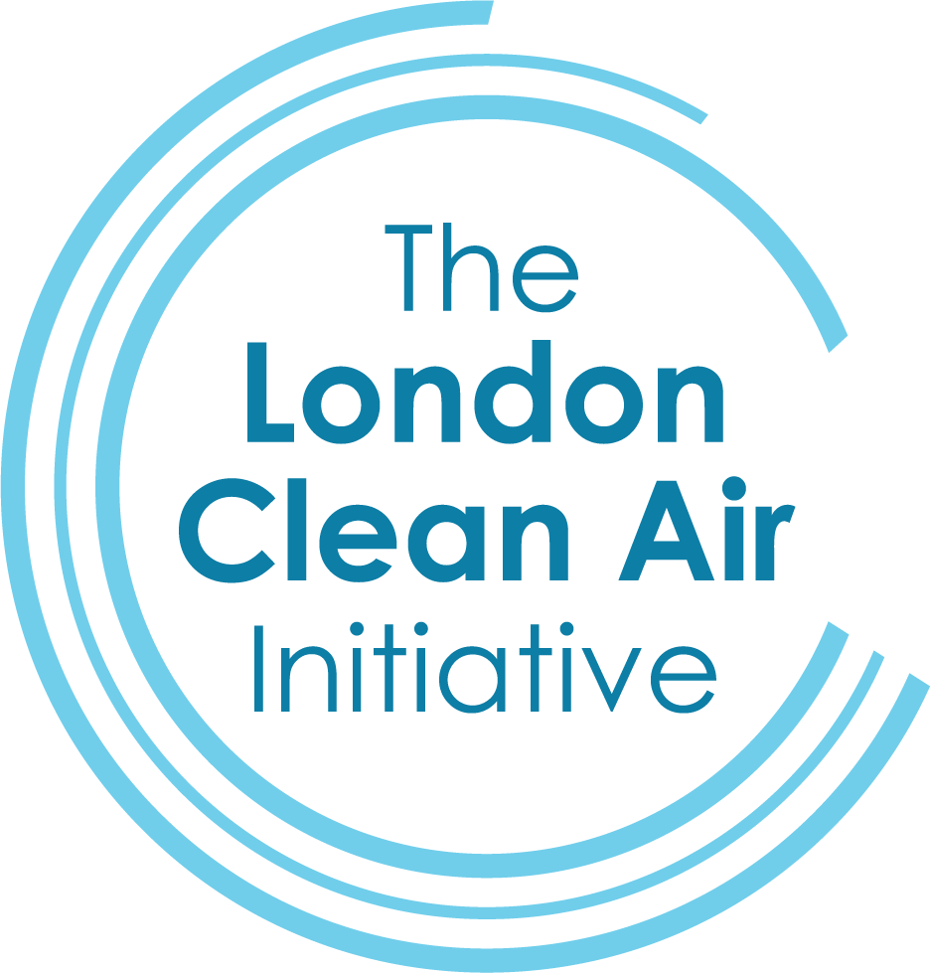

The Green Futures Event
Monday, October 5th, 2026 from 09:00 to 18:00
105 Victoria Street
London
SW1E 6QT

Event Overview
The Green Futures Event is designed to inspire and inform mainstream and SEND students aged 16+ about sustainable jobs and careers. This is a crucial age for them to start making the right choices regarding their ideal field of work, so the event features talks, workshops, and networking sessions with exhibitors from various industries.

Logistics:
Venue: 105 Victoria Street, London, SW1E 6QT (former House of Fraser building)

Public Transport:
- By Underground (Tube)
St James’s Park Underground station is approximately four minutes’ walk away, providing Circle and District line services. Victoria station is around six to eight minutes on foot and offers access to the Victoria, Circle and District Underground lines, together with extensive National Rail services across London and the South East.
- By Bus
The venue is well served by buses operating along Victoria Street and from nearby stops at Westminster City Hall and Victoria station. Routes include the 3, 11, 24, 26 and 148, providing convenient connections throughout Westminster and the wider central London area.
- By train
Victoria station is served by the following train companies:
Southern — services from south London, Surrey, Sussex and the south coast. Southeastern — services from south-east London and Kent.
Gatwick Express — dedicated direct services between London Victoria and Gatwick Airport.

Parking: Notes & Considerations

- Driving to Victoria is discouraged and the venue does not offer its own parking facilities.
- The venue is also located within the ULEZ and Congestion Charging Zones.
- Pay & Display is available at various locations around the area.
- There are several private/reservable car parks in the area. Reserving in advance often gives better certainty on availability and better pricing.

Programme Schedule

Exhibitor Arrival
08:00-09.00 – Exhibitors arrive to set up and network. Coffee, tea, and pastries will be offered throughout the morning. Please provide the names of all staff attending by Thursday 1/10.

Green Futures Event Opens
09:00 – 18:00: Career Fair Opens in and around “The Village”.

Talks & Workshops
Talks will happen in the “Sports Area” on the lower ground level.

Workshops will happen in several signposted rooms around “The Village”.
They will take place throughout the day at the following times:

9.15-9.45
10.00-10.30
11.15-11.45
12.00-12.30
13.20-13.50
14.00-14.30
15.15-15.45
16.00-16.30
16.45-17.15
17.30-18.00

Sessions:

School students will attend during 2x separate morning sessions. These are at:
9.00-11.00
11.00-12.45

Exhibitors’ Lunch:
12:45 – 13:15: Lunch will be offered to all exhibitors.

SEND Session:
13:15 – 14.30: A dedicated, quieter session for students with special educational needs will take place at this time, with a reduced schedule of talks and workshops, and less noise.

Break:
14.30-15.00: There will be another 30mins break after the SEND Schools Session

Adult Session:
15.00-18.00: The event opens to anyone over 18 who has registered to attend online via Eventbrite.

Green Futures Event Closes
18:00: Event ends. Exhibitors collect their materials and leave.

What to bring to the Career Fair:
- Tablecloth for your exhibitor’s table
- Banners
- Any item relevant to showing your business (e.g. sample tyres, wind turbines and solar panel models, simulators etc. – the more tangible, the better).
- Any marketing material (however single use items and plastics are discouraged)
- Please do not bring any sweets for the students.
- If you can, do send a minimum of two staff, as this will be a long day.

What will be provided:
- Wi-Fi
- Table and chairs.
- Lunch, plus tea and coffee throughout the day.
- Please check with the organisers that your stall has access to power before bringing laptops, as some stalls have sockets nearby, and some don’t. If you absolutely need power please let us know, and we will try to place your stall accordingly.

Deliveries:
- If you need to send anything to the venue directly, please contact Valeria at vpensabene@lcai.uk. Please ensure the name of your company is also written clearly on the package or we cannot ensure we will be able to locate it once it has been delivered.

Exhibitors’ guidelines:
The aim of these guidelines is to ensure consistency in communication and experience during the events organised by The London Clean Air Initiative (TLCAI).
- Appropriate dress, language, and behaviour are required at all times.
- Any presentation or talk must be appropriate to the age and maturity level of the student audience.
- Please refrain from taking photos or videos before and during the event. We will be sharing official photos a few days later. In particular please do not take any photos of anyone with a NO PHOTO sticker.

If you still have any questions, or for any problems on the day, please contact:
Antonia Welch, awelch@lcai.uk, 07502 154 843
Valeria Pensabene, vpensabene@camdencleanair.org, 07947 068 717

Thank you for your support, and we look forward to seeing you on October 5th!

